MY VILLAGE GODS AND THE MIGRATORY OYSTERS.
It was in 2011 and just like any other vacations, I was in town where one day I saw a group of women discussing among themselves about something. I was able to make out one woman who used to sell food in my basic school those days.
After exchanging greetings with her, I asked her what the gathering was about. she told me “the chief priest of the town, thus my town-Mepe in the North Torngu District of Volta Region- Ghana, had asked all the five clans in the town to each present one ram and foreign schnapps. And those items according to him were demanded by the gods to purify the main source of water-the Volta River to the community for the long extinct oysters to return to the area. I felt that was rather superstitious.
I quickly started to find a way to prove to the community that the chief priest’s claim could be pure fiction. The actual course of the oysters’ extinction became my priority. In June 13, 2012 after my senior High School, I had visited “Ada” – the only community along the Volta River where the oysters still are caught.
I became part of a diving team for three days and during this period; I had observed and appreciated the beautiful live style exhibited by these creatures. What I liked most was their social live, the colony forms a termite-like structure under the water yet; those at the bottom do not die or suffocate. Another thing that caught my attention was the absence of water weeds. I asked the leader of the team how come there were no weeds under the water like my town, he told me the weeds were there too, but where ever there were weeds, there were no oysters.
I got something very important from that. Oysters I know are sessile bivalves and could easily be restricted by water weeds. This I felt could be the cause of extinction of the oysters but I have to be sure. So I brought 20 oysters home and put them into a group of 10 in the same river. One group was put in a cage containing weeds and the other one without weeds and obtained the following results.
Experiment 1 | Hapas with water weed | Hapas without water weed | Duration before death
Death on life | 7/10 | 2/10 | First 12 days
Total no. of species dead after first 12 days,=09/20
After repeating the experiment for two more times, I had observed the following results below;
Experiment 2.

Death on life |  | 9/15 |  | 2/15 | First 16 days
Total no. of species dead after the first 16 days,=11/30
Experiment 3.
Death on life |  | 9/10 |  | 5/10 | First 10 days
Total no. of species dead after the first 10 days,=14/20
The three experiments were carried out at different parts of the river and based on the outcome, I felt there could be other factors contributing to the death of the oysters as recorded in the Hapas without water weed and that is what I intend to find out in my current level at the University for Development Studies-Ghana.
The extinction of these oysters had led to the closure of the local factory that processes oyster shell into chalk for the schools in the community and white-wash for painting of houses. A lot of my friends always have to travel to Ada to buy the oysters back home for sale during weekends to pay their school fees. Many households prefer oyster to fish because it is more affordable. Oysters’ shells were formally used for concrete work for building, because they were more affordable to the ordinary family as compared to pebbles and gravels. Also as a conservationist, I fear if Ada continues to be the only source of oyster to the entire nation, these creatures are doomed to extinction completely in the river sooner than later. Hence, a successful outcome of this project, might serve as a solution to the above problems.

.a) oysters sold by students during weekends. .b) a picture of the collapsed oyster shell factory.
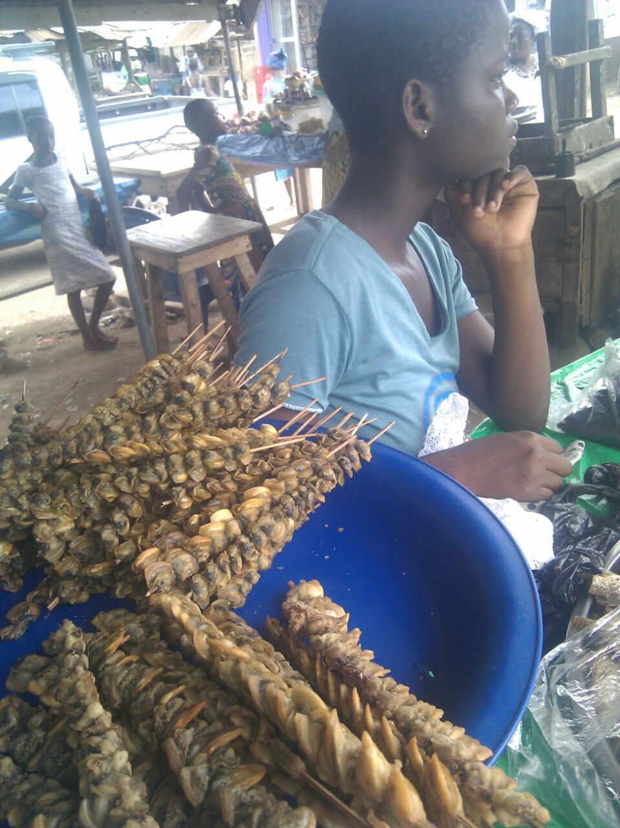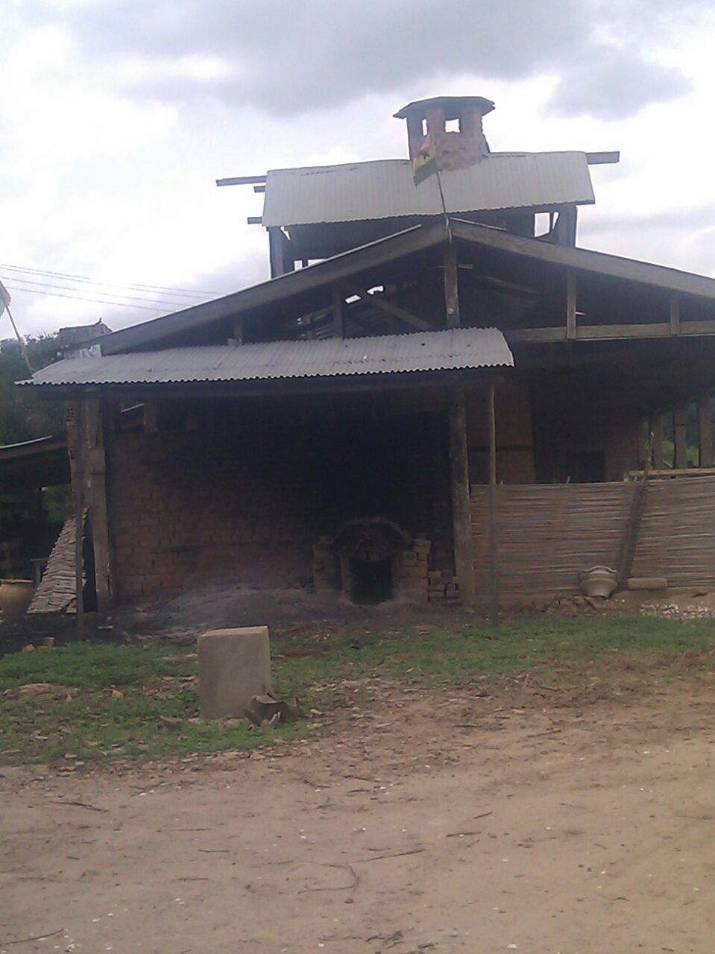
.c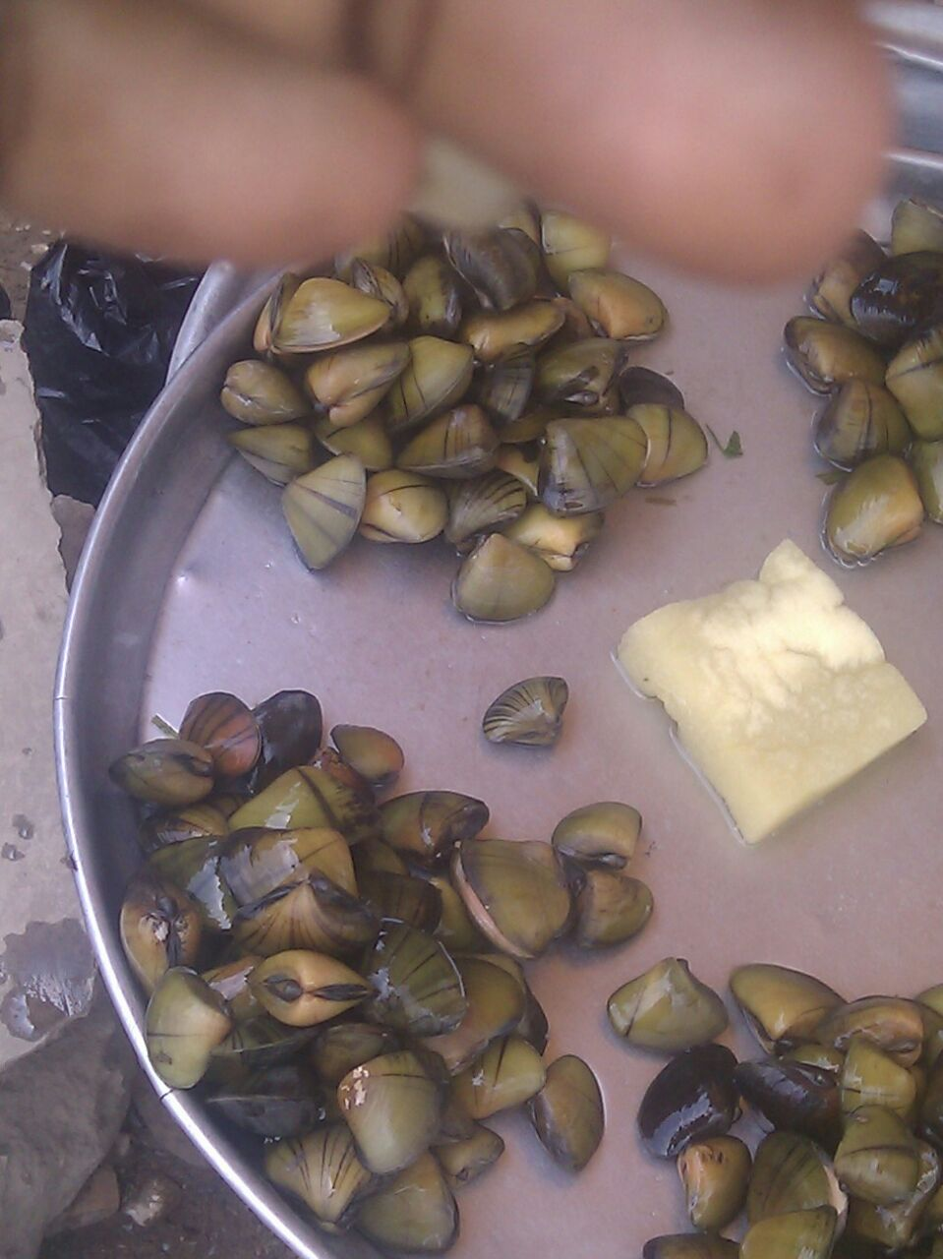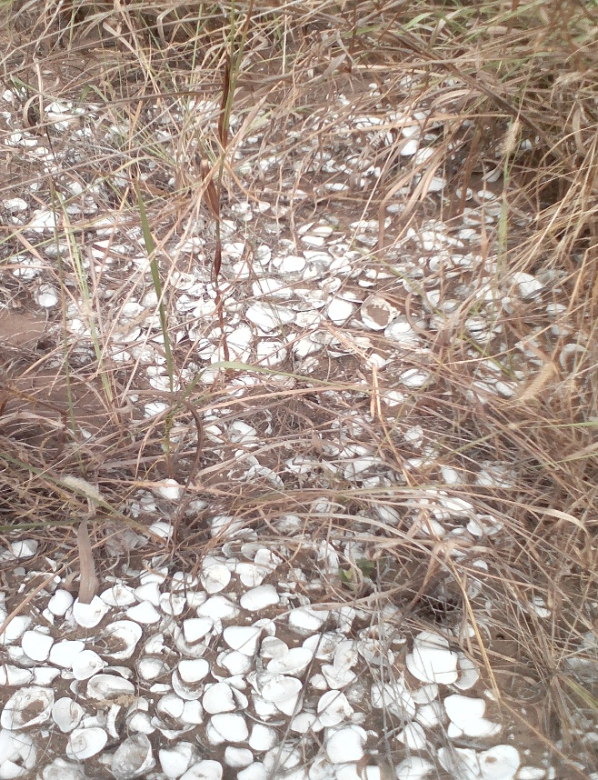
.c) fresh oysters sold by market women. .d) a picture of some extinct oysters.

