Consequences of Artificial Light Pollution on the Parental Behaviour of Freshwater Fishes
Ecological light pollution is when artificial lights disturb the natural functioning of individual organisms or their ecosystems. Increasing human development near shorelines has been leading to increased light pollution. This light pollution is coming from cottage, dock lights, vehicular traffic and urban sky glow of nearby cities. This could impact the functioning of near shoreline ecosystems in lakes and rivers. Smallmouth bass is a popular recreational angling fish that lives in freshwater systems throughout North America. Male bass provide sole parental care to their young by guarding their nest, day and night, for up to six weeks in the Spring. Nest guarding includes keeping the nest clean and scaring off nest predators such as smaller fish that consume eggs and young fish. Any alterations to the dad’s behavior – either directly because of the response to artificial light or indirectly due to changes is the activity of nest predators – could lead to increased energetic demands for the dad that has a fixed energy budget. The dad could become exhausted and reduce his nest defense or abandon the nest because he needs to feed. This could ultimately reduce reproductive success.
To examine this issue, students from the Carleton University Fish Ecology and Conservation Physiology Lab conducted field work in the Rideau River Watershed by externally attaching tri-axial accelerometer loggers to nesting smallmouth bass while their young were still eggs. We then subjected the bass to three treatments. The first fish group was a control group that was not subjected to any artificial light. The second light treatment group was subjected to low levels of continuous light to mimic nearby dock lights on a nest. The third light treatment group was subjected to high intensity irregular lighting to simulate vehicular traffic passing by.
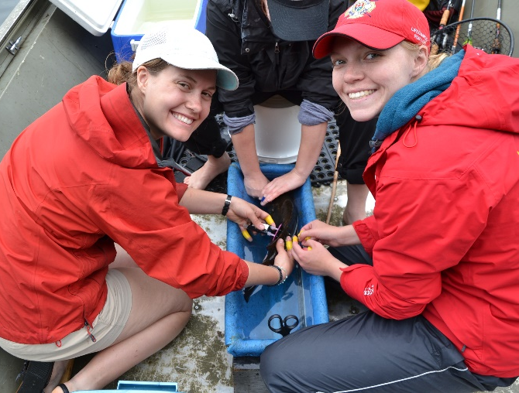
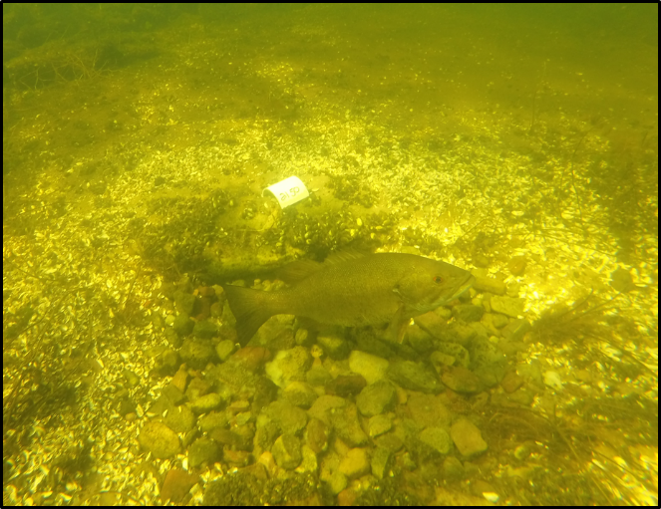
Our study used the activity level of the fish as a measurement of the amount of energy the dad used to guard his young. Our study revealed that both types of artificial light pollution increased overall bass activity level compared to the control group. The vehicular traffic treatment resulted in the highest fish activity level and showed large fluctuations between night and day activity level. During the day, the fish were very active and at night, the fish were not as active. Fish with the dock light treatment displayed higher activity than the control fish but did not fluctuate between night and day activity level. They were consistently active throughout.
Our results suggest that continuous and intermittent artificial light sources, common in shoreline habitats that have been developed, have the potential to alter the behavior and energy use of nest guarding fish. 60% of freshwater fish families exhibit parental care. These fish species make up a large portion of freshwater ecosystems and fill a critical niche in the way the system functions. If light pollution increases the energy use of parental fish, it may lead to increased nest abandonment and reduced offspring survival. This could have negative consequences for both the functioning of the ecosystem and the success of recreational angling. Lake-front land owners should be conscious of the artificial light that they are casting on freshwater habitats and the consequences that they could have.

